**Midterm Review Sheet #1**

**Name:_______________________________ Date:**

**Directions: Read each question carefully. Please show all work.**

1. Evaluate the expression  when x = 2 and y = -3. 1.____________

1. Solve the proportion: . 2.____________
2. The slope of the line that is parallel to the line that passes through (3, 4) 3.____________

and (-2, -6) is:

1. Solve . 4.____________
2. The equation of the line that is perpendicular to y = 5 and passes through 5.____________

the point (2, 3) is:

1. Write the equation of a line that has a slope of 4 and passes through the point (2, -1).

6.____________

1. Solve: 4x - (2x + 8) = -12

7.____________

1. Given g(x) = 3x + 12, find g(-3):

8.____________

1. Given f(x) = 4x2 and g(x) = x3 + 3x, find f(4) + g(-1).

9.____________

1. Given f(x) = 8x + 5 and g(x) = x2 + 7, find g(-2)  f(-2).

10.____________

1. If x = 4, then x3 - 28 = ?

11.____________

1. Solve the inequality: 4(x + 2) > -x, and graph the solution.

12.____________

**Midterm Review Sheet #2**

**Name:_______________________________ Date:**

**Directions: Read each question carefully. Please show all work.**

1. Find the slope of the line passing through the points (-3, 5) and (2, 7).

13.____________

1. Graph .

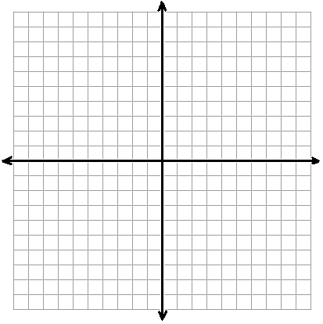

14.

1. Solve |3x - 2| = 32

15.____________

1. Solve the following system of equations: 

16.____________

1. Solve the following system of equations: 

17.____________

1. How many solutions does the system  have?

18.____________

1. Write the equation of the line that passes through (3, -2) and is perpendicular to the line y = 

19.____________

**Midterm Review Sheet #3**

**Name:_______________________________ Date:**

**Directions: Read each question carefully. Please show all work.**



20.

1. Graph the following inequality: 
2. Given the function *f(x) = 2x - 3* evaluate the following:
3. *f(-4)* a. _____________
4. *f(0)* b. _____________
5. *f* c. _____________
6. How do you determine if a graph represents a function?
7. **Explain** how to graph the line *y = -3x + 2*