**Graphing Polynomials Quick Quiz Review Part 2**

**Directions:** Be sure to show all work, communicate your thought process, and justify your reasoning. Remember to check that your answers are complete, correct, and reasonable. If you complete work on scrap paper, please attach it.

1. The polynomial -x5 – 5x4 + 17x3 + 17x2 – 32x – 28 has (x + 1) as a factor.

Sketch a graph of the polynomial.

Be sure to choose and state an appropriate y-scale, according to the y-intercept.

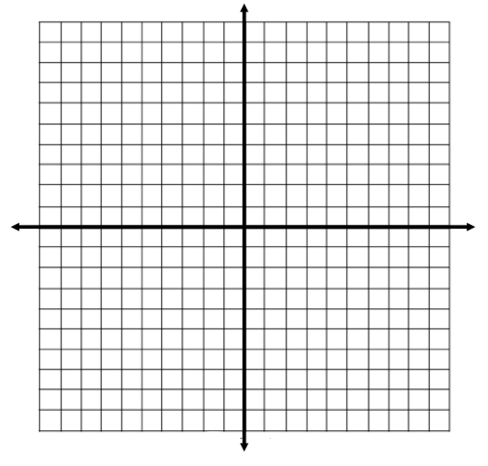

2. Consider the function b(x) = (2x – 9)(x + 2)2(x – 4)

**Part A:** What is the y-intercept?

**Part B:** Determine all of the x-intercepts of b(x), and their multiplicities

**Part C:** For which interval(s) is b(x) > 0?

x < -2 -2 < x < 1 1 < x < 4.5 x > 4.5

**Part D:** Write the description of the end behavior of the graph, in terms of x, f(x), , and -.