**Polynomials Test Review**

**Directions:** Be sure to show all work, communicate your thought process, and justify your reasoning. Remember to check that your answers are complete, correct, and reasonable.

1. One factor of v(x) = 2x3 + 3x2 – 32x + 15 is (x + 5).

a. Determine the x-intercepts and y-intercept of the graph of v(x). Write your answers as points.

b. Sketch the end behavior of the graph of v(x).

c. Describe the end behavior using the new notation we learned.

2. State the degree, & write the factored form for the function having the provided zeros.

a. Zeros: ¼ (M.3), -8, and 5(M.2)

b. Zeros: -4i and 2/3(M.2)

3. Factor the left side of each equation completely. Then solve.

a. r4 – 256 = 0. b. 3x3 – 8x2 + 3x – 8 = 0

c. k3 + 125 = 0 d. x4 – 15x2 – 16 = 0

4. Divide using long division. Write the full resulting quotient.

a. 6z4 + 3z3 – z2 + 2z – 5 ÷ (2z – 1) b. 8x3 + 12x – 5 ÷ (x – 4)

5. Write the function that has zeros at -2i, and -5.

6. Divide using synthetic division. Write the full resulting quotient.

Also state if the divisor is a factor or not.

a. 9x3 + 7x2 + 12 ÷ (x + 1) b. -8d5 + 4d4 + 6d – 3 ÷ (2d – 1)

7. Consider the function w(x) = 2x3 – 9x2 – 33x - 14.

a. State all possible rational roots of the function.

b. Prove or disprove whether -2 is a root of the function.

c. Determine all roots of the function.

8. Consider the function t(x) = (4x – 3)(-x – 2)2(x - 8).

a. What is the y-intercept?

b. Determine the x-intercepts, and their multiplicities.

c Which most accurately describes the end behavior of the graph of t(x)?

a. as and as



b. as and as



c. as and as



d. b. as and as 



d. Sketch a graph of the function, and state an appropriate y-scale:

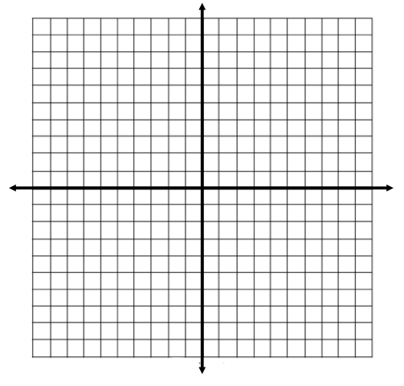

9. Perform each operation.

a. (6h2 – k2 + 9) + (9k3 – k2 – 20) b. (8b2c – 11b2 + 9b – c2 + 2) – (3b2 + b2c– 8b + 5)

c. (3w3 – 8w + 5)(2w – 1)

10. If 3 - 8*i* is a root of a polynomial, what else must be a root? ________

11. Observe each graph, and answer the following:

|  |  |
| --- | --- |
| plane.png  Roots (and multiplicities): ______________________________________  Degree: _____________________  Sign of Leading Coefficient: _________________ | plane.png  Roots (and multiplicities): ______________________________________  Degree: _____________________  Sign of Leading Coefficient: _________________ |
| plane.png  Roots (and multiplicities): ______________________________________  Degree: _____________________  Sign of Leading Coefficient: _________________ | plane.png  Roots (and multiplicities): ______________________________________  Degree: _____________________  Sign of Leading Coefficient: _________________ |