Name: _____________________________________________________________

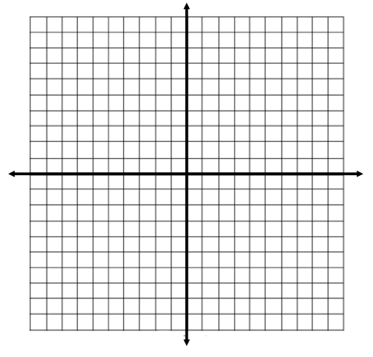
Introduction to Lines and Slopes Quiz Practice Problems

1. Create a table of values to graph the line given by the equation y = -3x + 2.
x | y

2. Match each equation to the most appropriate statement.

y = -10x + 4 _______ a. The line has positive slope.
y = -9 _______ b. The line has negative slope.
x = 4 _______ c. The line has zero slope.
y = 9x - 3 _______ d. The line has an undefined slope.

3. Label each line as horizontal, vertical, or neither.

a. x = -3 ______________________________ c. -2x – 8y = 0 ______________________________

b. y = -6 ______________________________ d. y = 20x ______________________________

4. Which point(s) lie on the line given by the equation 4x – 2y = 8?
There may be more than one answer!

(-1, 1) (-2, -8) (1, 2) (1, -2) (-5, -14)

5. Determine the x-intercept and y-intercept of the line given by -4y + 8x = 16.

6. Graph the line 3x - 6y = 36 using the x-intercept and y-intercept.

7. Determine the slope of each line.
a.  Slope: | b.  Slope: | c.  Slope:

8. Determine the slope of the line containing each pair of points.

a. (18, 23) and (-21, 23) b. (-9, -18) and (-9, 12)

c. (-4, 15) and (2, 9) d. (12, -8) and (-12, -20)

9. True/False: If the line is vertical, the slope is zero. _____________

10. True/False: All lines in the form y = p, where p is any real number, are vertical. _____________

