1. The average speed of cars on a given road is 27 mph. 68% of these speeds fall between and 25.5 and 28.5 mph. Determine the standard deviation of the data set.

2. The average speed of cars on a given road is 38 mph. 99.7% of these speeds fall between and 34.4 and 41.6 mph. Determine the standard deviation of the data set.

3. Consider a normal distribution.

a. What percent of the values would you expect to fall outside of one standard deviation of the mean?

b. What percentage of the values would you expect to fall below two standard deviations of the mean?

4. Consider a thirty point exam, Exam A, for which μ = 23.3 and σ = 1.8.

a. One exams score corresponds to a z-score of 2.3. Determine the exam score.

b. One exams score corresponds to a z-score of -0.6. Determine the exam score.

c. Determine and interpret the z-score for a student who scored 21.5 out of 30 on the exam.

d. On another thirty point exam, Exam B, the average score was 27.3 and standard deviation was 1.99. Is this exam more or less consistent than exam A? Explain.

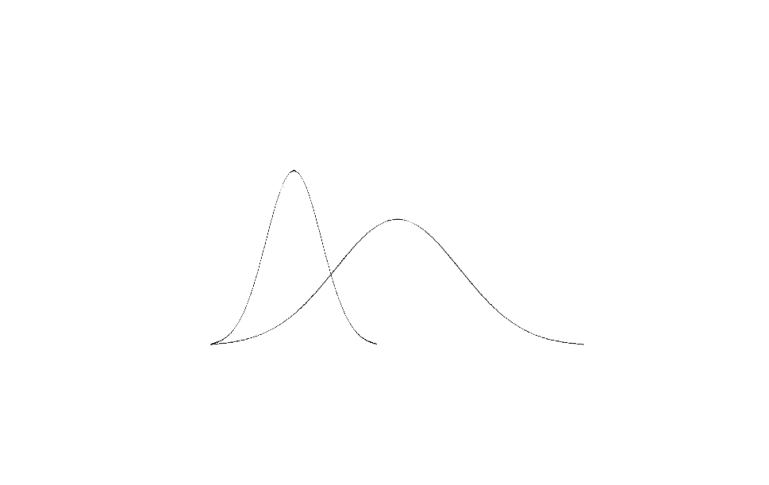5. The average speed Maria runs at per week is 6.7 mph, with a standard deviation of 0.40 mph. On Friday, Maria ran at a steady pace of 6.9 mph. Determine and interpret the corresponding z-score.

X

Y

6. A student claims that data set X has a higher mean, while data set

Y has a higher standard deviation. To what extent to you agree or

disagree with this claim? Explain, in terms of the definitions of

standard deviation and mean.

7. A handheld game is found to have a mean battery life of 24 hours, normally distributed, with standard deviation 2.5 hours. If a store has 750 of the games to sell, approximately how many of these handheld games would you expect to stay on without being charged for less than 19 hours? If you were to purchase one of these games, what is the probability that your game would last more than 31½ hours without being charged?

8. At a local gym, every fifth person who enters between 8:00 AM and 3:00 PM four Fridays in a row is surveyed about how many hours per week they participate in cardiovascular exercise at the gym. The results showed that the average number of hours was six, with a standard deviation of 2.25 hours. A trainer at the gym also recommends to participants in the study that they participate in at least 3¾ hours of cardiovascular exercise per week.

a. What type of sampling is this?

b. Is this study biased? If so, suggest a better way to collect data in order to avoid bias. If you believe there is no bias, explain why.

c. Describe any interval of hours that you would expect 47.5% of the people to participate in cardiovascular exercise for.

d. What percent of the people would you expect to be reaching the cardiovascular recommendation made by the trainer?

9. Describe the general qualities of a study in which bias is unlikely. (There are at least two!)