Quadratic Functions Pre-Unit Review

Objective: You will be able to rewrite and graph quadratic functions .

What Am I?!

When factoring, you should always look for me first… | I am a different way of writing (a + b)²…

Don’t Let Four Terms Through You for a Loop…

When you have four terms, first make two ___________!

1. 3d³ + 7d² - 3d – 7 2. 16x³ + 72x² – 10x – 45 3. 27m³ + 36m² – 3m – 4

You may not always want to guess and check;
Use the grouping method to avoid a trek!
To do this you will need to rewrite “b”
As a sum of factors of “_______.”

1. 54r³ – 30r² – 4r 2. 6q⁸ – 5q⁴ – 6

3. 24p² – 60p + 24
4. 10x⁶ – 33x³ - 7

Graphs
Essential Aspects:
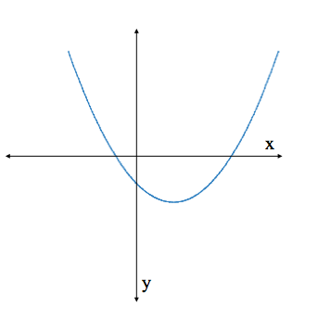

I wouldn’t want graphing to take you all day…
Each type of equation will help you along the way!
Each of these makes some part(s) so clear to see –
Know them very well, and EASY will graphing be!

Intercept Form Vertex Form

Standard Form (factorable) Standard Form (not factorable)

Can You Solve These Puzzles?! (I know you can! )

Puzzle A: Function d(x) = x² and function c(x) = -6 –x.

~ What are the solutions to d(x) + h(x) = 0?! ~ What are the solutions to 3d(x – 1) – 6h(x) = 0?!

Puzzle B: m² – 6m – 7 – x(m – 7)² = 0

~ If m = 7, what could the value of x be?! _____________
If m = 5, x must be _____________!

Now pretend each seven were changed to a nine,  and any value of x would make the equation work fine.  Also replace the 6 with a “v”,  Then figure out what “m” and “v” must be! | m² – vm – 9 – x(m – 9)² = 0  is true for all real numbers, x.  What are the values of m and v?

Puzzle C: How many different ways can you rewrite A⁴ – 81 + (A² – 9)² ?! List as many as possible!

Puzzle D: There exists a much simpler, shorter way to write (k³ + j³)² – (k³ – j³)².
Can you figure it out?!

*Check Unit 5 HW on the website for the homework problems & homework puzzles! (All required )
Graphing Quadratic Functions Examples

1. f(x) = –(x + 2)² – 3 2. f(x) = (x – 3)(x + 5)

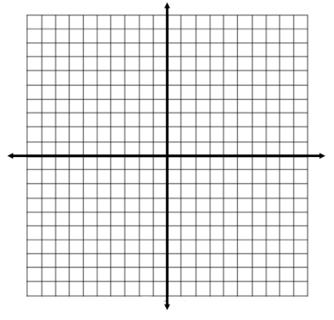
3. f(x) = -x² + 4x + 12 4. f(x) = x² - 6x + 9

5. f(x) = -2x² – 8x – 11 6. f(x) = 3x² –6x + 1

Graphing Quadratic Functions Practice
For each function,
- State the form the function is in.
- Determine the transparent aspects.
- Create a graph of the function using three points, on graph paper.
*Be sure to identify your x-scale and y-scale!

1. f(x) = -2x² + 8x - 10 2. f(x) = 2x² – 2x – 12

3. f(x) = (2x – 4)(x + 5) 4. f(x) = -(x + 4)² + 1

5. f(x) = 4x² – 12x + 9 6. f(x) = 4x² – 16x + 3

7. f(x) = -(x + 3)² – 7 8. f(x) = x² + 16x + 60

Graphing Quadratic Functions Homework
For each function,
- State the form the function is in.
- Determine the transparent aspects.
- Create a graph of the function using three points, on graph paper.
*Be sure to identify your x-scale and y-scale!

1. f(x) = -(x – 8)(4x + 4) 2. f(x) = x² + 16x + 64

3. f(x) = -3x² – 24x + 2 4. f(x) = -(x - 1)² – 3

5. f(x) = x² – 49 6. f(x) = x² – 6x + 8

7. f(x) = (x + 2)² – 9 8. f(x) = 4x² - 4x – 24

9. Throwback: a. Rewrite #4 in standard form. b. What is the domain & range in #6?

Graphing Quadratic Functions Practice
*Identify the function(s) that will have imaginary solutions.
*Identify the function(s) in which the vertex is the same as the x-intercept.
*Identify the function(s) in which the vertex is the same as the y-intercept.
1. 2.

3. 4.

5. 6.

7. 8.
Graphing Quadratic Functions Homework
*Identify the function(s) that will have imaginary solutions.
*Identify the function(s) in which the vertex is the same as the x-intercept.
*Identify the function(s) in which the vertex is the same as the y-intercept.

1. 2.

3. 4.

5. 6.

7. 8.

