***I know you will learn and grow from correcting and understanding your mistakes. Please let me know if you have questions.***

***Being proficient in these skills is extremely important for you to be successful throughout this and further courses, and will make your mathematical experiences MUCH more smooth and enjoyable!*** ☺

**#1, 2, and 5 Types of numbers**

Videos: <https://www.khanacademy.org/math/cc-eighth-grade-math/cc-8th-numbers-operations/cc-8th-irrational-numbers/v/recognizing-irrational-numbers>

<https://www.khanacademy.org/math/cc-eighth-grade-math/cc-8th-numbers-operations/cc-8th-irrational-numbers/v/categorizing-numbers>

Notes:

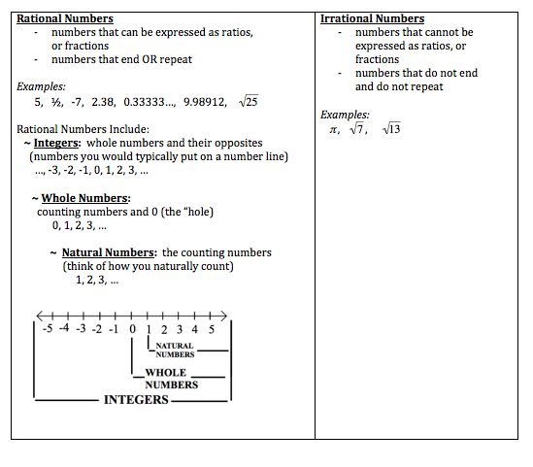

*If the negative sign is under the square root symbol, the number is imaginary.

**#3 Fraction conversion**

Videos: <https://www.khanacademy.org/math/arithmetic/fraction-arithmetic/arith-review-mixed-number/v/changing-a-mixed-number-to-an-improper-fraction>

<https://www.khanacademy.org/math/arithmetic/fraction-arithmetic/arith-review-mixed-number/v/changing-an-improper-fraction-to-a-mixed-number>

Examples:  = 2 wholes and , so 

 is  so 

**#6 Fraction operations:**

Videos: <https://www.khanacademy.org/math/arithmetic/fraction-arithmetic/arith-review-multiply-fractions/v/multiplying-a-fraction-by-a-fraction>

<https://www.khanacademy.org/math/arithmetic/fraction-arithmetic/arith-review-dividing-fractions/v/conceptual-understanding-of-dividing-fractions-by-fractions>

<https://www.khanacademy.org/math/cc-seventh-grade-math/cc-7th-negative-numbers-add-and-subtract/cc-7th-add-sub-neg-fractions/v/adding-and-subtracting-three-fractions>

Examples:

Multiplication:  Division:  

Subtraction: 

**#7:** Remember the fact that if $0 is shared among 10 people, each person receives $0, but if $10 is shared among 0 people, we do not know what would happen to the money, and therefore call this case undefined

**#8:** Remember the order of operations (exponents are applied before multiplication)

Remember that absolute value is always positive

Take your time with your signs

**#9:**

The word “product” means multiplication.

The phrase “is no more than” means less than or equal to

The word "difference" means subtraction (example: the difference of a number and 9 is x - 9)

The word “per” signifies multiplication if information is given (example, if pears cost $1.50 per bag and bananas cost $2 per bundle, the total cost would be 1.5p + 2b, where p is the number of bags of pears, and b is the number of bundles of bananas.)

**#10:** Remember, to solve a proportion, cross multiply. Be sure to distribute appropriately.

Example: 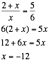

Check by substituting your final back into the original equation to make sure you did not make any minor calculation errors.

**#11:** To convert a percent to a decimal, move the decimal point 2 spaces to the left. For example, 54.3% is 0.543.

**#12:** If the variable disappears and you are left with a true statement, there are infinite solutions. If the variable disappears and your are left with a false statement, there are no solutions.

Notes:

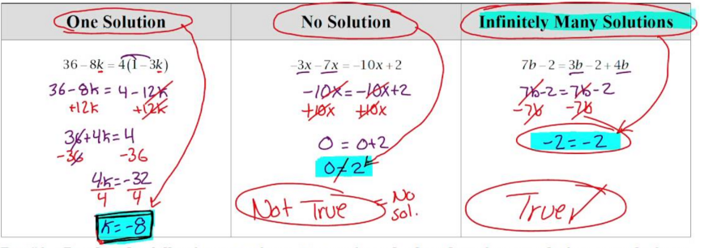

**#13**: Remember to apply exponents before multiplying. After multiplying, combine like terms. Remember (x + 2)2 means (x + 2)(x + 2) so x2 + 4x + 4

Example: 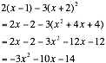

**#14** Evaluating expressions with negatives

Example: If x = 3, then 

**#15:** Remember < and > are situations in which the value is NOT included.

Remember when multiplying or dividing by a negative number, you must flip the direction of the inequality sign.

**#16:** Remember when multiplying or dividing by a negative number, you must flip the direction of the inequality sign.

Example: Solve for y.



**#17:** Remember (a + b)2 means (a + b)(a + b), NOT a2 + b2,

because that is missing the middle term.

**#18:** Use the distributive property twice, or “foil,” and remember to be careful with your signs.

Example: (9x + 1)(3x – 8) = 27x2 - 72x + 3x – 8 = 27x2 – 69x - 8

**#19:** Slope formula is: 

Video: <https://www.khanacademy.org/math/algebra/two-var-linear-equations/slope/v/slope-of-a-line-2>

Example: The slope between (3, -4) and (-2, 8) is:



**#20:** Vertical lines run up and down, and all pass through the same x-value. The slope is undefined.

Horizontal lines run across, and all pass through the same y-value. The slope is 0.

Video: <https://www.khanacademy.org/math/algebra/two-var-linear-equations/hor-and-ver-lines-alg1/v/examples-of-slopes-and-equations-of-horizontal-and-vertical-lines>

**#21:** Remember in the order of operations, multiplication comes BEFORE subtraction.

**#22:** To find any x-intercept, substitute in zero for y, since at the point where a graph crosses the x-axis, the value for y is zero.

To find any y-intercept, substitute in zero for y, since at the point where a graph crosses the x-axis, the value for y is zero.

Video: <https://www.khanacademy.org/math/algebra/two-var-linear-equations/x-and-y-intercepts/v/x-and-y-intercepts>

**#23:** Rearrange to slope intercept form if possible.

Example: 8x + 4y = 24 becomes 4y = -8x + 24, which is y = -½x + 6

Slope: -½ y-intercept: (0,6) x-intercept: 8x + 4(0) = 24, so x = 3, so

the point (3,0)

*Slope can be counted as rise over run.

Video: <https://www.khanacademy.org/math/algebra/two-var-linear-equations/slope/v/slope-of-a-line>

x-intercepts are in the form (x, 0), so to find an x-intercept, use y = 0 and solve for x

y-intercepts are in the form (0, y), so to find a y-intercept, use x = 0 and solve for y

Example: In 3x + 4y = 12, the x-intercept is (x, 0)

so 3x + 4(0) = 12, so x = 4 implying the point (4,0)

The y-intercept is (0,y) so 3(0) + 4y = 12, so y = 3 implying the point (0,3)

*Intercepts are coordinate points, not just numbers.

More Videos:

<https://www.youtube.com/playlist?list=PLxwSdVGkDunqOW33I1Mpx9UcD6dB20EBU>

**#24:** Parallel lines have the same slope (example: y = **5**x + 6 and y = **5**x - 9)

Perpendicular lines have opposite reciprocal slope (example: y = **¼**x – 2 and y = **-4**x + 7)

**#25 and 27:** Factoring

Videos:

<https://www.khanacademy.org/math/algebra/polynomial-factorization/factoring-quadratics-1/v/factoring-quadratic-expressions>

<https://www.khanacademy.org/math/algebra/polynomial-factorization#factoring-polynomials-1-common-factors>

<https://www.khanacademy.org/math/algebra/polynomial-factorization/factoring-quadratics-1/a/factoring-quadratics-leading-coefficient-1>

<https://www.khanacademy.org/math/algebra/polynomial-factorization/factoring-quadratics-diff-of-squares/a/factoring-quadratics-difference-of-squares>

Examples:

 

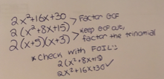

**#26:** Graphing lines

Videos: <https://www.youtube.com/playlist?list=PLxwSdVGkDunqOW33I1Mpx9UcD6dB20EBU>

<https://www.khanacademy.org/math/algebra/two-var-linear-equations/graphing-slope-intercept-equations/v/graphing-a-line-in-slope-intercept-form>

<https://www.khanacademy.org/math/algebra/two-var-linear-equations/standard-form/v/plotting-x-y-relationships>

*To graph x = a number, find the number on the x-axis, and extend the tick mark through the axis

*To graph y = a number, find the number on the y-axis, and extend the tick mark through the axis

**#28:** Zero product property:

Video: <https://www.khanacademy.org/math/algebra/quadratics/factored-form-alg1/v/zero-product-property>

Example: (x - 4)(x + 3)(2x - 1) = 0 means that

x - 4 = 0 or x + 3 = 0 or 2x -1 = 0, so x = 4, -3 or 1/2

**#29 and 30:** Exponent properties

*When in doubt, write it out!

*Anything to the zero power is 1.

Examples:  NOT x5

 

 

 

Videos: <https://www.khanacademy.org/math/pre-algebra/pre-algebra-exponents-radicals/pre-algebra-exponent-properties/v/exponent-properties-involving-products>

<https://www.khanacademy.org/math/pre-algebra/pre-algebra-exponents-radicals/pre-algebra-negative-exponents/v/negative-exponents>

**#31a**Cube roots

*cube root means what times itself 3 times will give you the number, for example, the cube root of 64 is 4 because 4*4*4 = 36, the cube root of 125 is 5 because 5*5*5 is 125

Video: <https://www.khanacademy.org/math/algebra/rational-exponents-and-radicals/alg1-radicals/v/introduction-to-cube-roots>

**#31b** Square roots

Video: <https://www.khanacademy.org/math/algebra/rational-exponents-and-radicals/alg1-simplify-square-roots/v/simplifying-square-roots-comment-response>

***I hope this helps.  Let me know if you have any questions!***

Ms. Boruch