Name: ________________________________ Midterm Review 2017

The Questions I have about the review problems are…
(feel free to write more questions on scrap paper)

In order to answer these questions, I will

Ask my teacher Ask a peer/family member

Use my textbook/notes as a reference Use online references

Other ___________________________________________________

After checking my work, I will redo the problem numbers below on the following pages:

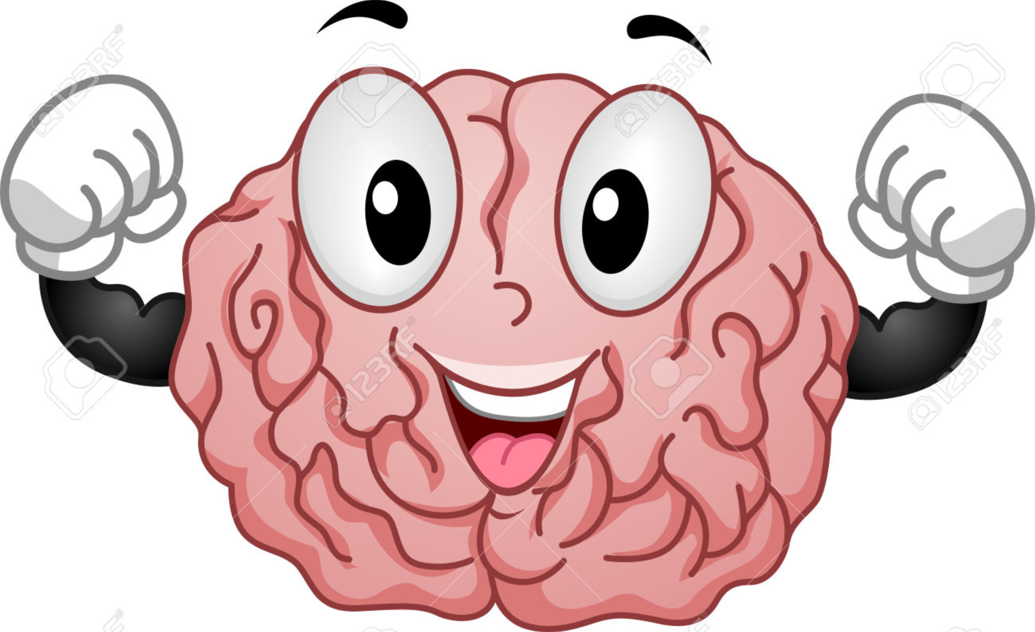
Strengthen Your Brain!

Page: _______ Problem # _____
My Mistake Was  Due To… | Here is my new work  and new solution. | I corrected my  mistake by…
Calculation error  Reading error  I did not understand  Careless mistake  I guessed  Other: ____________  ____________________  ____________________ |  | Reviewed notes/textbook  Corrected minor calculations  Asked my teacher  Asked a peer/family member  Other: ________________  ________________________  ________________________  I still need help with this concept.  I feel better about this concept now.

If someone were to ask “why” about any part of this problem, I would respond with… (feel free to explain in words, use visuals, etc. This is the most important part! )

Page: _______ Problem # _____
My Mistake Was  Due To… | Here is my new work  and new solution. | I corrected my  mistake by…
Calculation error  Reading error  I did not understand  Careless mistake  I guessed  Other: ____________  ____________________  ____________________ |  | Reviewed notes/textbook  Corrected minor calculations  Asked my teacher  Asked a peer/family member  Other: ________________  ________________________  ________________________  I still need help with this concept.  I feel better about this concept now.

If someone were to ask “why” about any part of this problem, I would respond with… (feel free to explain in words, use visuals, etc. This is the most important part! )

Page: _______ Problem # _____
My Mistake Was  Due To… | Here is my new work  and new solution. | I corrected my  mistake by…
Calculation error  Reading error  I did not understand  Careless mistake  I guessed  Other: ____________  ____________________  ____________________ |  | Reviewed notes/textbook  Corrected minor calculations  Asked my teacher  Asked a peer/family member  Other: ________________  ________________________  ________________________  I still need help with this concept.  I feel better about this concept now.

If someone were to ask “why” about any part of this problem, I would respond with… (feel free to explain in words, use visuals, etc. This is the most important part! )

Page: _______ Problem # _____
My Mistake Was  Due To… | Here is my new work  and new solution. | I corrected my  mistake by…
Calculation error  Reading error  I did not understand  Careless mistake  I guessed  Other: ____________  ____________________  ____________________ |  | Reviewed notes/textbook  Corrected minor calculations  Asked my teacher  Asked a peer/family member  Other: ________________  ________________________  ________________________  I still need help with this concept.  I feel better about this concept now.

If someone were to ask “why” about any part of this problem, I would respond with… (feel free to explain in words, use visuals, etc. This is the most important part! )

Page: _______ Problem # _____
My Mistake Was  Due To… | Here is my new work  and new solution. | I corrected my  mistake by…
Calculation error  Reading error  I did not understand  Careless mistake  I guessed  Other: ____________  ____________________  ____________________ |  | Reviewed notes/textbook  Corrected minor calculations  Asked my teacher  Asked a peer/family member  Other: ________________  ________________________  ________________________  I still need help with this concept.  I feel better about this concept now.

If someone were to ask “why” about any part of this problem, I would respond with… (feel free to explain in words, use visuals, etc. This is the most important part! )

Page: _______ Problem # _____
My Mistake Was  Due To… | Here is my new work  and new solution. | I corrected my  mistake by…
Calculation error  Reading error  I did not understand  Careless mistake  I guessed  Other: ____________  ____________________  ____________________ |  | Reviewed notes/textbook  Corrected minor calculations  Asked my teacher  Asked a peer/family member  Other: ________________  ________________________  ________________________  I still need help with this concept.  I feel better about this concept now.

If someone were to ask “why” about any part of this problem, I would respond with… (feel free to explain in words, use visuals, etc. This is the most important part! )

Page: _______ Problem # _____
My Mistake Was  Due To… | Here is my new work  and new solution. | I corrected my  mistake by…
Calculation error  Reading error  I did not understand  Careless mistake  I guessed  Other: ____________  ____________________  ____________________ |  | Reviewed notes/textbook  Corrected minor calculations  Asked my teacher  Asked a peer/family member  Other: ________________  ________________________  ________________________  I still need help with this concept.  I feel better about this concept now.

If someone were to ask “why” about any part of this problem, I would respond with… (feel free to explain in words, use visuals, etc. This is the most important part! )

Page: _______ Problem # _____
My Mistake Was  Due To… | Here is my new work  and new solution. | I corrected my  mistake by…
Calculation error  Reading error  I did not understand  Careless mistake  I guessed  Other: ____________  ____________________  ____________________ |  | Reviewed notes/textbook  Corrected minor calculations  Asked my teacher  Asked a peer/family member  Other: ________________  ________________________  ________________________  I still need help with this concept.  I feel better about this concept now.

If someone were to ask “why” about any part of this problem, I would respond with… (feel free to explain in words, use visuals, etc. This is the most important part! )

Page: _______ Problem # _____
My Mistake Was  Due To… | Here is my new work  and new solution. | I corrected my  mistake by…
Calculation error  Reading error  I did not understand  Careless mistake  I guessed  Other: ____________  ____________________  ____________________ |  | Reviewed notes/textbook  Corrected minor calculations  Asked my teacher  Asked a peer/family member  Other: ________________  ________________________  ________________________  I still need help with this concept.  I feel better about this concept now.

If someone were to ask “why” about any part of this problem, I would respond with… (feel free to explain in words, use visuals, etc. This is the most important part! )

Page: _______ Problem # _____
My Mistake Was  Due To… | Here is my new work  and new solution. | I corrected my  mistake by…
Calculation error  Reading error  I did not understand  Careless mistake  I guessed  Other: ____________  ____________________  ____________________ |  | Reviewed notes/textbook  Corrected minor calculations  Asked my teacher  Asked a peer/family member  Other: ________________  ________________________  ________________________  I still need help with this concept.  I feel better about this concept now.

If someone were to ask “why” about any part of this problem, I would respond with… (feel free to explain in words, use visuals, etc. This is the most important part! )

Page: _______ Problem # _____
My Mistake Was  Due To… | Here is my new work  and new solution. | I corrected my  mistake by…
Calculation error  Reading error  I did not understand  Careless mistake  I guessed  Other: ____________  ____________________  ____________________ |  | Reviewed notes/textbook  Corrected minor calculations  Asked my teacher  Asked a peer/family member  Other: ________________  ________________________  ________________________  I still need help with this concept.  I feel better about this concept now.

If someone were to ask “why” about any part of this problem, I would respond with… (feel free to explain in words, use visuals, etc. This is the most important part! )

Page: _______ Problem # _____
My Mistake Was  Due To… | Here is my new work  and new solution. | I corrected my  mistake by…
Calculation error  Reading error  I did not understand  Careless mistake  I guessed  Other: ____________  ____________________  ____________________ |  | Reviewed notes/textbook  Corrected minor calculations  Asked my teacher  Asked a peer/family member  Other: ________________  ________________________  ________________________  I still need help with this concept.  I feel better about this concept now.

If someone were to ask “why” about any part of this problem, I would respond with… (feel free to explain in words, use visuals, etc. This is the most important part! )

Page: _______ Problem # _____
My Mistake Was  Due To… | Here is my new work  and new solution. | I corrected my  mistake by…
Calculation error  Reading error  I did not understand  Careless mistake  I guessed  Other: ____________  ____________________  ____________________ |  | Reviewed notes/textbook  Corrected minor calculations  Asked my teacher  Asked a peer/family member  Other: ________________  ________________________  ________________________  I still need help with this concept.  I feel better about this concept now.

If someone were to ask “why” about any part of this problem, I would respond with… (feel free to explain in words, use visuals, etc. This is the most important part! )

Page: _______ Problem # _____
My Mistake Was  Due To… | Here is my new work  and new solution. | I corrected my  mistake by…
Calculation error  Reading error  I did not understand  Careless mistake  I guessed  Other: ____________  ____________________  ____________________ |  | Reviewed notes/textbook  Corrected minor calculations  Asked my teacher  Asked a peer/family member  Other: ________________  ________________________  ________________________  I still need help with this concept.  I feel better about this concept now.

If someone were to ask “why” about any part of this problem, I would respond with… (feel free to explain in words, use visuals, etc. This is the most important part! )

Page: _______ Problem # _____
My Mistake Was  Due To… | Here is my new work  and new solution. | I corrected my  mistake by…
Calculation error  Reading error  I did not understand  Careless mistake  I guessed  Other: ____________  ____________________  ____________________ |  | Reviewed notes/textbook  Corrected minor calculations  Asked my teacher  Asked a peer/family member  Other: ________________  ________________________  ________________________  I still need help with this concept.  I feel better about this concept now.

If someone were to ask “why” about any part of this problem, I would respond with… (feel free to explain in words, use visuals, etc. This is the most important part! )

Page: _______ Problem # _____
My Mistake Was  Due To… | Here is my new work  and new solution. | I corrected my  mistake by…
Calculation error  Reading error  I did not understand  Careless mistake  I guessed  Other: ____________  ____________________  ____________________ |  | Reviewed notes/textbook  Corrected minor calculations  Asked my teacher  Asked a peer/family member  Other: ________________  ________________________  ________________________  I still need help with this concept.  I feel better about this concept now.

If someone were to ask “why” about any part of this problem, I would respond with… (feel free to explain in words, use visuals, etc. This is the most important part! )

Page: _______ Problem # _____
My Mistake Was  Due To… | Here is my new work  and new solution. | I corrected my  mistake by…
Calculation error  Reading error  I did not understand  Careless mistake  I guessed  Other: ____________  ____________________  ____________________ |  | Reviewed notes/textbook  Corrected minor calculations  Asked my teacher  Asked a peer/family member  Other: ________________  ________________________  ________________________  I still need help with this concept.  I feel better about this concept now.

If someone were to ask “why” about any part of this problem, I would respond with… (feel free to explain in words, use visuals, etc. This is the most important part! )

Page: _______ Problem # _____
My Mistake Was  Due To… | Here is my new work  and new solution. | I corrected my  mistake by…
Calculation error  Reading error  I did not understand  Careless mistake  I guessed  Other: ____________  ____________________  ____________________ |  | Reviewed notes/textbook  Corrected minor calculations  Asked my teacher  Asked a peer/family member  Other: ________________  ________________________  ________________________  I still need help with this concept.  I feel better about this concept now.

If someone were to ask “why” about any part of this problem, I would respond with… (feel free to explain in words, use visuals, etc. This is the most important part! )

Need more pages?! Just let me know!

