**Graphing Polynomials Quick Quiz Review**

**Directions:** Be sure to show all work, communicate your thought process, and justify your reasoning. Remember to check that your answers are complete, correct, and reasonable. If you complete work on scrap paper, please attach it.

1. The polynomial 2x3 - 13x2 – 48x + 27 has (2x - 1) as a factor. Sketch a graph of the polynomial. Be sure to choose and state an appropriate y-scale, according to the y-intercept.

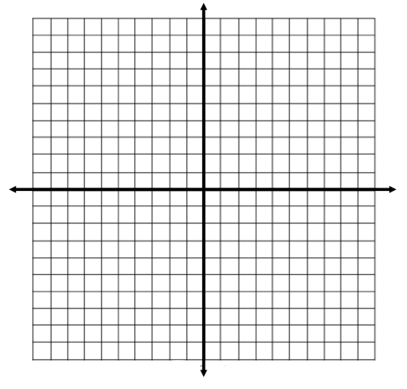

2. Consider the function p(x) = (x + 11)(-2x + 1)(x – 8)

**Part A:** What is the y-intercept?

**Part B:** What are the x-intercepts?

**Part C:** Consider the intervals provided. For which interval(s) is p(x) < 0?

x < -11 -11 < x < 0.5 0.5 < x < 8 x > 8

**Part D:** Which most accurately describes the end behavior of the graph?

a. as and as 

b. as and as 

c. as and as 

d. as and as 