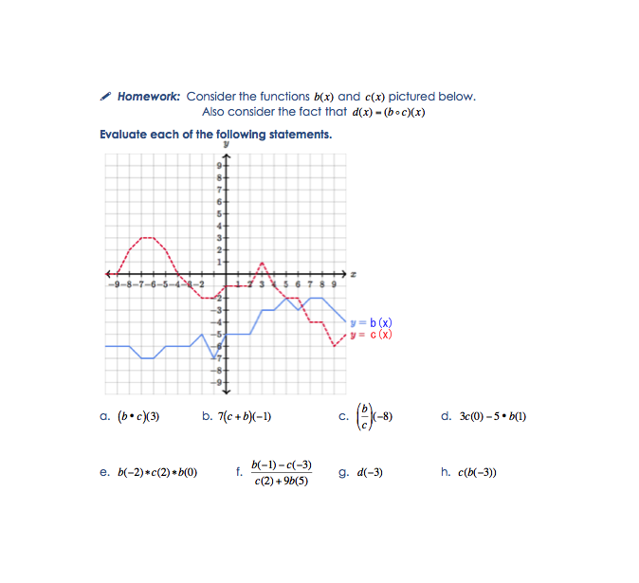

Bonus!
Complete and turn in on a separate sheet of paper to earn homework extra credit!

Day 1: Sketch a graph of any two functions, h(x) and k(x) such that 2(h – k)(4) = 4.

Day 2: Sketch a graph of any three functions, v(x), w(x) & z(x), such that v(w(z(-1)) = 9.

Solutions on next page!

Solutions:
