**Domain & Range Homework Day 2**

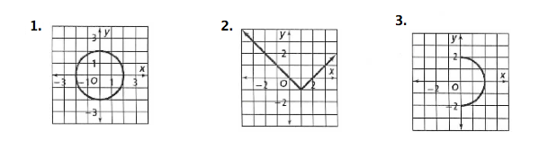**Directions:** For each relation, state the domain and the range. Then explain whether or not each relation is a function, as well as why.

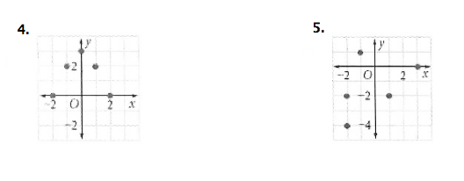

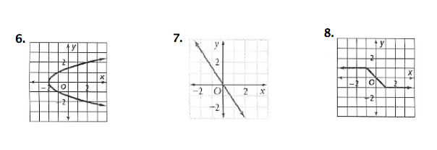

*Check your answers on the next pages.* ☺

**Solutions**

