**Graphing Linear Functions Extra Practice**

**Understanding the basics of linear functions and being able to accurately graph lines is extremely essential for success regarding future units, especially modeling problems and algebraic systems. Please watch the videos that correspond to the problems that you answered incorrectly on the pre-assessment. Try the new practice problems that correspond with these problems as well, and check your answers. Please see me to review and/or to ask any questions you have! You will be assessed on these skills again soon!**

1. a. What is the slope between the points (9,7) and (-3,13)? Show and explain all work.

b. What is the slope between the points (-4,4) and (-4,8)? Show and explain all work.

c. What is the slope between the points (-4,5) and (14,5)? Show and explain all work.

d. What is the slope between the points (8,4) and (-8,9)? Show and explain all work.

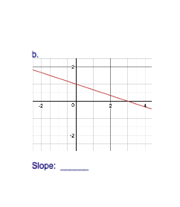

2. What is the slope of each line?

a. y = -x + 12

Slope: _______

c. -8y = 9 – 5x

Slope: _______

d. 7x = y - 4

Slope: _______

e. y = 5 f. x = 3

Slope: _______ Slope: _______

3. Determine the x-intercept and y-intercept of each line.

|  |  |
| --- | --- |
| a. Macintosh HD:Users:boruch:Desktop:Screen shot 2016-10-21 at 6.18.12 PM.png  x-intercept: __________  y-intercept: __________ | b. Macintosh HD:Users:boruch:Desktop:Screen shot 2016-10-21 at 6.18.38 PM.png  x-intercept: __________  y-intercept: __________ |

4. Consider the line given by the equation -6x + 12y = 60.

a. What is the x-intercept? Show and explain all work.

b. What is the y-intercept? Show and explain all work.

5. A line is parallel to the line given by the equation y = -½x - 5.

What is the slope of the parallel line?

6. A line is perpendicular to the line given by the equation y = -9x -3.

What is the slope of the perpendicular line?

7. Graph each line.

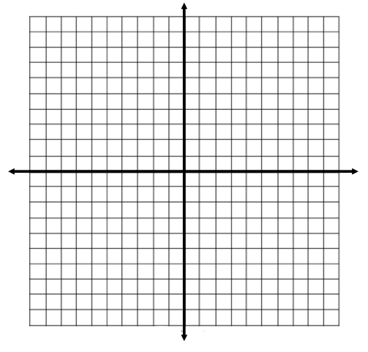

a. y = -¾x + 5 b. y = -3x

c. 3y – 4x = -12 d. x = 2

 

e. y = -9 f. 5y = -x - 10

 