~ Problems 1 – 4
*Order of Operations: GEMDAS
Grouping Symbols (including absolute value, radicals, parentheses, etc.)
Exponents
Multiplication/Division in Order of Appearance
Addition/Subtraction in Order of Appearance
*Remember absolute value is the distance a number is from zero, so once you simplify inside the absolute value bars, make the final value positive when you drop the bars!

~ Problems 5 – 10
* Axis of Symmetry: is given by the equation x =
This line is also halfway between the x-intercepts.
* Vertex: is on the axis of symmetry (and is also known as the maximum or minimum value)
Substitute in the x-value of the axis of symmetry to the function to find the output, or y-value of the vertex
* Maximum/Minimum:
- If a is positive, the parabola opens up, thus having a minimum value at the
y-coordinate of the vertex.
- If a is negative, the parabola opens down, thus having a maximum value at the
y-coordinate of the vertex.

https://www.youtube.com/watch?v=8fXo31u9zOY

~ Problems 11 & 12
* x-intercepts occur when the value of y is zero. You can factor and set each factor equal to zero to find these points, OR use the quadratic formula to find these points. If the discriminant, b² – 4ac, is negative, you will end up with a negative number under the radical when applying the quadratic formula, thus resulting in imaginary roots, and therefore NO x-intercepts (the graph will never cross the x-axis).

https://www.youtube.com/watch?v=MqIpwRD-bLA

~ Problems 13 and 14
- Simplify distribute in any signs to the parentheses, drop the parentheses, and combine like terms. Terms must have the exact same variable to the exact same exponent in order to be like. For example, 3x²y and -4x²y are like terms, but 3x²y and -4xy² are not.

https://www.youtube.com/watch?v=T0a92gEDukY

~ Problem 15
Don’t let four terms throw you for a loop, when you have four terms form two groups!
(Factor by grouping)

https://www.youtube.com/watch?v=rR4FfB-FZJw

~ Problem 16
*Factor normally, but remember that the first terms must multiply to x⁸.

*Example: If the first term in the trinomial were x¹², the first terms in your binomials would be x⁶ because x⁶ * x⁶ = (x * x * x * x * x * x) * (x * x * x * x * x * x), which is x¹²

*Don’t forget to look for differences of squares! In those cases, you can factor into:
(square root of the first + square root of the second)(square root of the first – square root of the second)
Example: x² – 49 = (x – 7)(x + 7)
But remember x² + 49 = (x – 7i)(x + 7i) since i² is -1.
https://www.youtube.com/watch?v=jmbg-DKWuc4

~ Problems 17 and 18
*Set each factor equal to zero and solve.
*Remember to take both the positive and negative square root if square rooting both sides of an equation.
*You may need to use the quadratic formula if you have a trinomial that you cannot factor further.

~ Problems 19 and 20
Remember these terms from class…
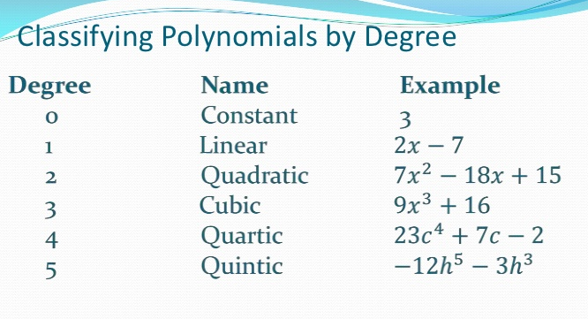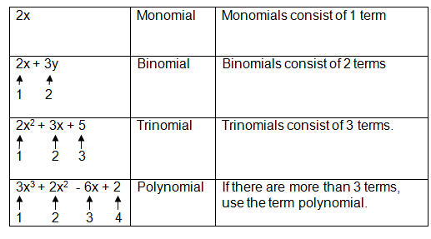

~ Problems 21 and 22
Discriminant is b² – 4ac, which is under the radical in the quadratic formula.
Square root of a positive results in two real solutions.
Square root of a negative results in two imaginary solutions.
Square root of 0 results in one real solution, since +√0 is the same as -√0.

https://www.khanacademy.org/math/algebra/quadratics/solving-quadratics-using-the-quadratic-formula/v/quadratic-formula-3

