Solving Non-Linear Systems Homework

Directions: Be sure to show all work, communicate your thought process, and justify your reasoning. Remember to check that your answers are complete, correct, and reasonable. Do not forget to complete the “Throwback” problems!

*If you do not have a graphing calculator, use the one at this link:
https://www.desmos.com/calculator

1. Use a table of input and output values to illustrate for which whole number value of x the functions v(x) and w(x) will be equivalent, given that v(x) = -|x – 3| and
w(x) = -2(x)² – 2.

2. Given the functions c(x) = -(x + 1)² and d(x) = -|x|- 7, determine the value(s) of x for which c(x) = d(x). Where necessary, round to the nearest tenth.

3. For each system of equations, determine the amount of intersection points. Do not use a calculator.

System | No Points of Intersection | One Point of Intersection | Two Points of Intersection
y = 4 – x²
y = 2 - x
y = 4 – x²
y = 5 - x
y = 4 – x²
y = 4
y = 4 – x²
y = 4/x
y = 4 – x²
y = 8/x²

4. Given the functions f(x) = -¼|x – 2| and g(x) = -(x)² + 3, which intervals contain a value of x for which f(x) = g(x)?

-3 ≤ x ≤ -2 -2.3 ≤ x ≤ -1.7 -1 ≤ x ≤ -0.5

0 ≤ x ≤ 1 1.3 ≤ x ≤ 2.3 3.5 ≤ x ≤ 4

5. Functions p and q are defined below. The graphs of y = p(x) and y = q(x) intersect at point P. Determine the x-coordinate of P, rounded to the nearest tenth.

6. Three functions intersect at exactly one point. If the functions are defined as
a(x) = 2x – 1, b(x) = |3x |-1, and c(x) = ½x² – 1, determine the x-coordinate of the common intersection point.

7. One of the systems below will not have any solutions. Without using a calculator, determine which system will have no solutions, and support your choice.

System A. y = x² – 7 System B. y = -x² + 2 System C. y = -x² - 9
y = -3 y = 2 y = 3

8. Two companies earn different profits on the same product for up to 2500 units manufactured. The following equations model the profit (y) earned by each company when x units are sold.

Company A: y = -0.005x² + 20x – 5000

Company B: y = 7.5x

Determine the number of units for which both companies would earn the same profit.

*Hint: Scale your graph appropriately –
the minimum scale should be 1000 for both x and y.

Throwback!

1. Select all of the values that can be placed in the empty cell so that the table satisfies the definition of a function.

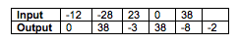
2 -12 -3

38 0 -8

2. A taxicab charges a certain initial fee, and a constant rate per mile. After 2.5 miles, the meter reads $4.05, and after six miles, the meter reads $6.57. Define and describe the meaning of each term in a function model (equation) that could be used to determine the cost of the taxi fare, c, after m miles.

Selected Solutions:
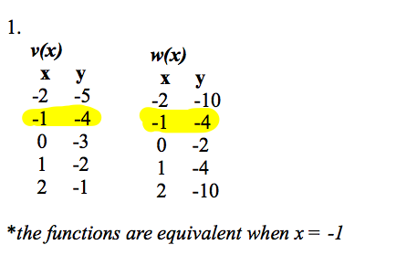
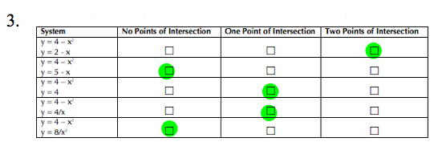
5. x = -1.5

7. System C will not have any solutions, since the vertex of the quadratic is at (0,-9) and the parabola opens down, which is in the opposite direction from the function y = 3.

8. If 500 units or 2000 units are sold, both companies will earn the same profit.

Throwback 1: