**Introduction to Quadratics Quiz Review Sheet**

**Directions:** Be sure to show all work, communicate your thought process, and justify your reasoning. Remember to check that your answers are complete, correct, and reasonable. If you complete work on scrap paper, please attach it.

1. *Consider each function.*

b(x) = 16x10 + 22x5 c(x) = -3 d(x) = x2 f(x) = 3 – 2x

g(x) = b(x) + c(x) h(x) = d(x + 1) j(x) = 2d(x – 1) – 4f(x)

a. Factor g(x) completely. b. What is the maximum of -g(x)?

c. Determine the x-intercepts, y-intercept, axis of symmetry, and vertex of d(x) – f(x).

d. Solve j(x) = 4x. e. Solve j(x) = 6.

2. Factor each expression completely.

a. 24m3 – 54m2 – 15m b. 27 – 363v4 c. Q4 – 625

3. Simplify each expression.

a.  b.  c. 

4. Solve each equation.

a. 3x2 + 24 = 0 b. 4p2 – 24 = 0 c. m2 = -16

5. Determine the vertex of each function.

a. y = (x + 8)2 – 9 b. m(x) = 2x2 – 20x + 3 c. g(x) = x2 – 49

6. Determine the x-intercepts of each function.

a. w(x) = x2 – 16 b. t(x) = x2 – 10x + 9 c. r(x) = x2 + 4x + 4

7. Determine the y-intercept of each function.

a. p(x) = x2 – 25 b. f(x) = -(x – 3)2 + 2 c. 2x2 – 5x + 10

8. Determine the minimum value of each function.

a. y = x2 – 8x – 2 b. y = ½(x + 1)2 – 2

9. Determine the maximum value of each function.

a. y = -½(x + 2)2 – 4 b. y = -2x2 – 2x – 4

10. Graph each function. Be sure that your graph contains at least three perfect points.

a.  b. 

*What would be true about the function’s roots if it were

changed to y = (x – 3)2 + 2?! How do you know?!

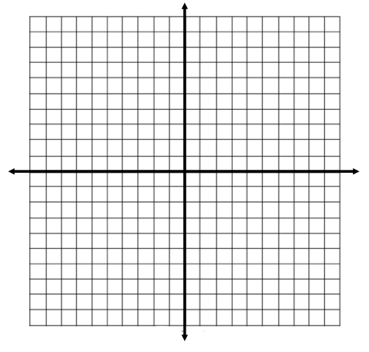 

11. Consider the function y = A(x + 2)2 - 8.

What must be true about the value of A for the function to have no real roots? Explain.

12. (p4 +c4)2 + p4c4 – (p4 – c4)2 = R(p8c8). Determine the value of R.

13. Factor each expression as much as possible.

a. x4 – 81 b. (q2 – 3)(q2 + 5) + (q2 + 3)(q2 + 5) c. 3b8 – 24b2

13. Choose a value for p & a value for d such that the equation below will have infinite solutions for x.

p2 – x(p – 3)3 + 8d = 10

14. Some of the functions below have the exact same vertex.

Select all of the functions that have the same vertex.

⭘ ⭘ ⭘

⭘ ⭘ ⭘

15. Consider the functions:

q(x) = x2

r(x) = 2x + 3

**Part A:** Graph the function given by q(x) – r(x). **Part B:** Simplify q(x – 3) + 2r(x).

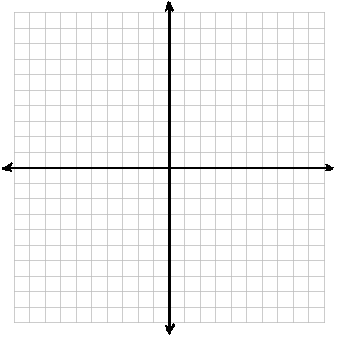

16. More factoring practice… ☺

a. c2 – 324 b. 9x2 – 6x + 1 c. v2 – v – 20

d. 24 – 150p4 e. 72k4 + 192k2 + 128 f. 8x2 – 16x – 10

g. 3w3 – 33w2 + 54w h. 3x2 + 5x – 12 i. 6r2 – r - 1

*You can also practice most of these quadratics skills on Khan Academy & ixL.com.