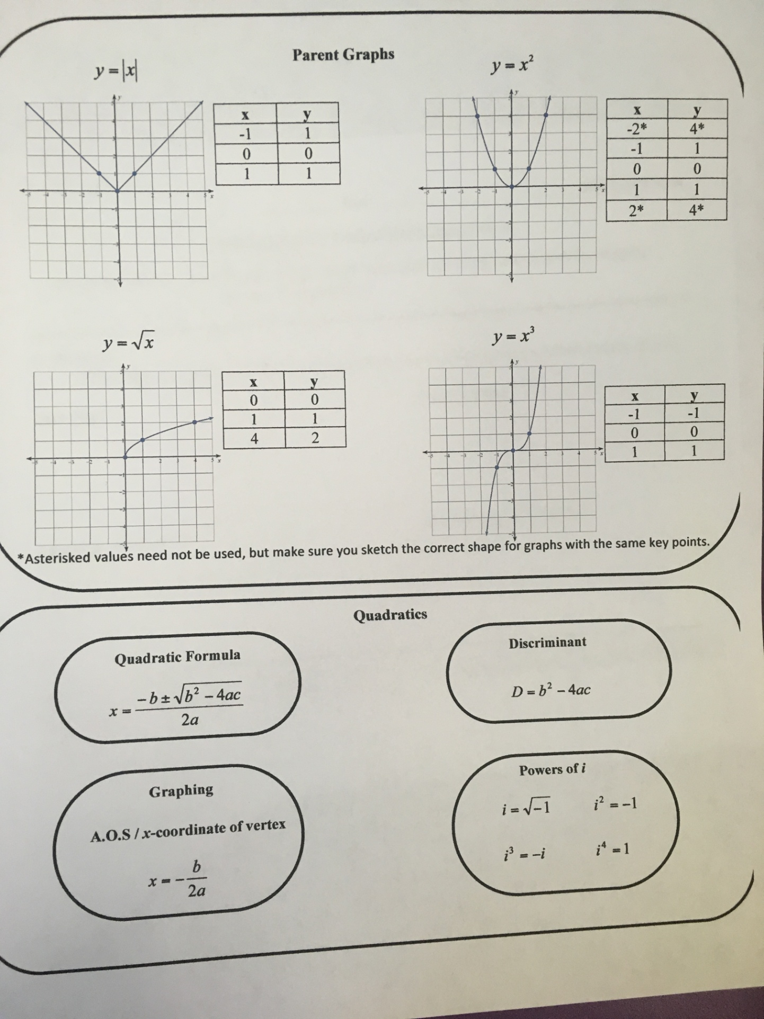

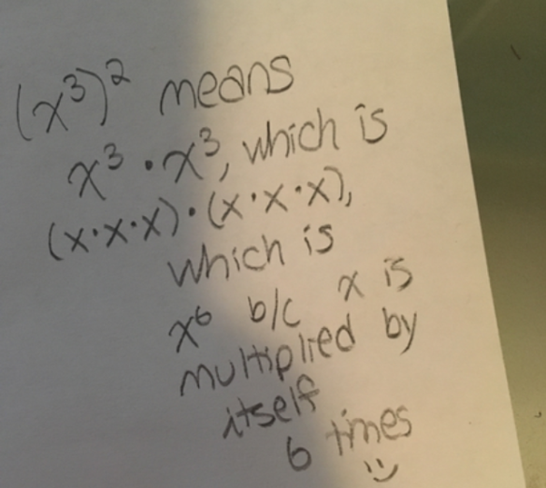 | *Solve intricate equations by graphing each side using a graphing calculator, and determining the x-value(s) at the point(s) of intersection.  *When checking the number of solutions to a system of non-linear functions, sketch a graph of each using the transformation rules (up/down, left/right, reflect, etc.)  *Axis of Symmetry: always x = the x-coordinate of the vertex (easy to determine if given in transformation form; use x = -b/2a if given in standard form)  *To find a third and second point to graph a quadratic, use an x-value close to the vertex, determine the y-value, and then reflect that point over the axis of symmetry, OR use the slope of the function.
*Be careful to double check all of your signs! | *When both variables cancel out in a system, you will either have a true statement (all real numbers/infinite solutions) OR a false statement (no solutions/parallel lines)
*Always look for a GCF first when factoring  *If you have four terms, form two groups and factor by grouping.  *If you have two terms, see if they are a difference of squares.  *Use the sites below for a reference on the AC method for factoring!  http://www.bates.ctc.edu/Documents/Tutoring%20Center/Tutoring_ACmethodwksheet.pdf  https://www.youtube.com/watch?v=RoeNm4LF9YQ | *A function is a relation in which each input maps to exactly one output.  *f(x) = y  *f(input) = output  [parentheses do not mean multiplication here!]  *2f(4) means two times “f of 4” OR 2 times the y-value of the function when x is 4  * (f ○ g)(x) means “f of g of x,” which means to first evaluate g(x), and then input this for x in f(x).  *(f•g)(x) means f(x) times g(x)
*Domain is all inputs, or x-values; Range is all outputs, or y-values  * ( ) are used for open circles or infinity; [ ] are used for closed points; { } are used for sets of discontinuous points  *Even symmetry: symmetric about y-axis; f(x) = f(-x)  *Odd symmetry: symmetric about the origin; f(-x) = -f(x) | * Af(Bx + C) + D  A: if negative, reflects over x-axis  |A| > 1, slope is steeper, so graph becomes more narrow  |A| < 1, slope is flatter, so graph widens  B: if negative, reflects over the y-axis  C: positive moves left and negative moves right  D: positive moves up and negative moves down
*Other names for “solutions,” are: roots, zeros, x-intercepts  *A function that has “no real roots” will never cross the x-axis | *Solve systems of linear functions using the elimination or substitution methods
*Always remember to test a point when shading a graph of an inequality | *A solution to a system should satisfy all equations in the system.
*The solution to a system occurs at the point of intersection of the graphs in the system. | *Rewrite powers of i in terms of i squared, remembering that i squared is -1  * i represents the square root of -1
*After distributing, get rid of the parentheses, and combine like terms if possible. | *You can solve quadratic equations by factoring, taking square roots, or the quadratic formula.
*The y-intercept is the point when the value of x is zero  (crosses y-axis).  *The x-intercept(s) is/are the point(s) when the value of y is zero (crosses x-axis).  *Max/Min of a quadratic occurs at the vertex | *Multiply by the conjugate in the numerator and denominator to simplify fractions with imaginary numbers.  *The conjugate of 3i is -3i.  *The conjugate of 2 + 5i is 2 – 5i.  *Standard form for complex numbers:  Real + imaginary

